Jan theeuwes – additional singleton paradigm

Is this a problem or an additional measurement that could be useful?

Is the stroop component of the task too complicated for clinical pop?

Simpler design? Consider having things vary by the same dimensions between different visConds

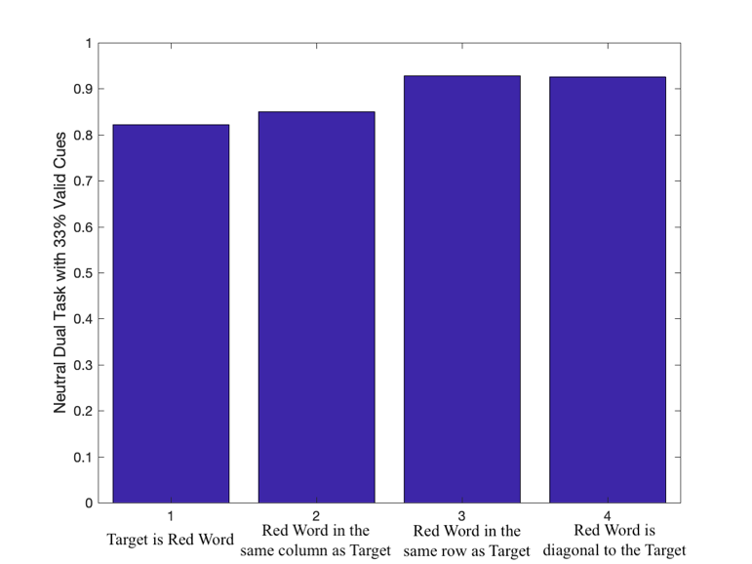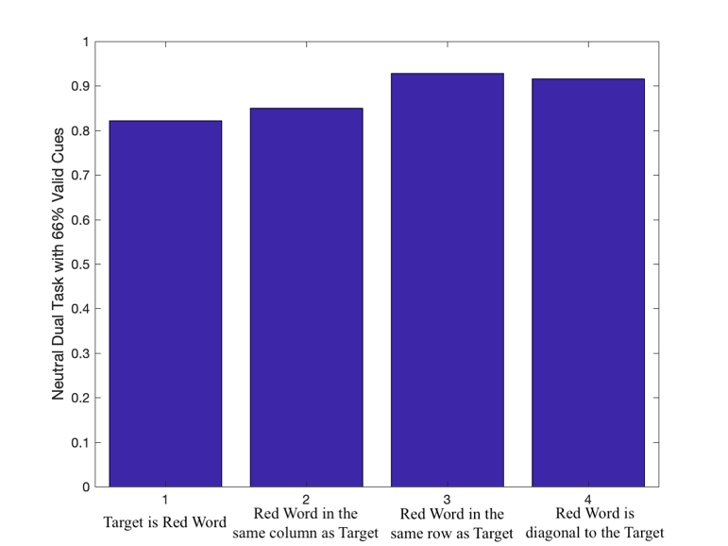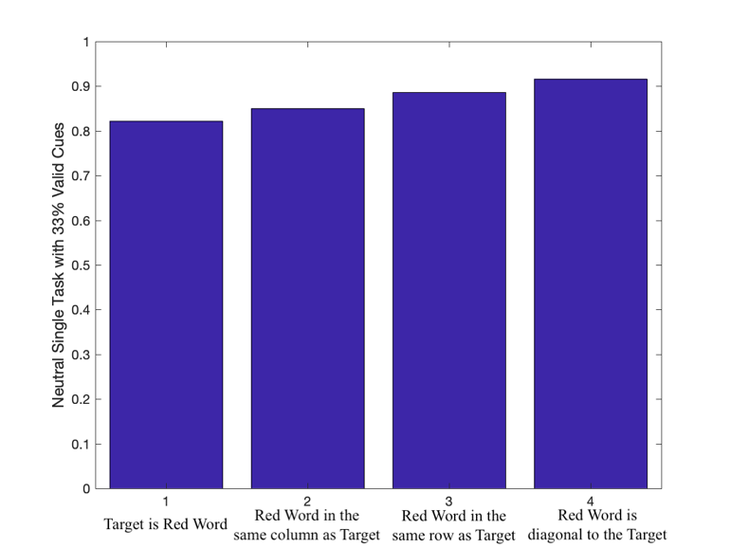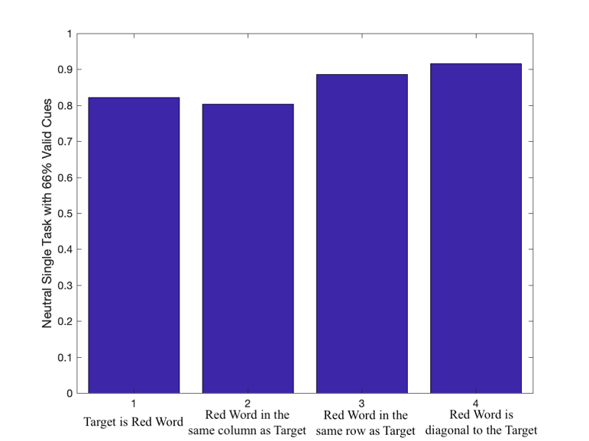

To

Or

At

If

To

Or

At

If

To

Or

At

If

To

At

Or

If